**Solution**

**University of Engineering and Technology, Taxila**

**Department of Industrial Engineering**

**Examination: Mid Semester Examination- April 2015**

**Class: Industrial Engineering (Entry 2012)-6th Semester**

**Course Title: Production Planning & Control (IE-324)**

**Maximum Marks: 8+32=40 __________ Time:02 hrs**

Student Name : --------------------------- Student Roll No. : ---------------------------

**Note :** Objective type question Part A to be completed within first **10 minutes** and return to the examination staff before attempting the Subjective Part B.

**Question No.1 : Encircle the suitable answers. 08 marks**

1. Time horizon for aggregate planning is normally

**(1) 6 to 18 months** (2) 5 years or more (3) 6 to 10 weeks

1. In inventory ABC group policy Group C represents the range of items carried in inventory
2. 10 to 20 % **(2) 75 to 85 %** (3) 7 to 10 %
3. The re order level in the inventory management is
4. When inventory replenishment is carried out
5. **Orders are placed for replenishment of inventory**
6. Stockout in the inventory level is observed
7. The range of correlation coefficient (r) is
8. **-1 to +1** (2) 0 to +1 (3) -1 to 0
9. In forecasting techniques, linear regression is classified as
10. Time series model **(2) Associative model** (3) All of the above
11. Delphi method is an important forecasting tool in
12. Statistical forecasting
13. **Judgmental forecasting**
14. None of the above
15. In linear regression equation with negative linear relationship, the slope is
16. Positive (2) Zero **(3) Negative**
17. “ Best Fit” in Estimated Regression Equation means difference between actual y- values and predicted y- values is
18. Maximum **(2) Minimum** (3) none of the above

**University of Engineering and Technology, Taxila**

**Department of Industrial Engineering**

**Examination: Mid Semester Examination- March 2014**

**Class: Industrial Engineering (Entry 2011)-6th Semester**

**Course Title: Production Planning & Control (IE-324)**

**Maximum Marks: 40 Time: 2hrs**

**Note:**

* **Borrowing is not allowed.**
* **Electronic gadgets except simple calculator are not allowed.**

Q.2) Write short answers to the following questions: 2×5=10

1. Explain briefly the characteristics of Static Deterministic Inventory Model and Dynamic Probabilistic Inventory Model

***Answer:***

**Static Deterministic Inventory Model:**

In these models, the demand is deterministic in nature (total number of units demanded over a fix period of time is known and constant), and the demand rate is the same for every period.

**Dynamic Probabilistic Inventory Model:**

The demand is random variable having a probability distribution that depends on the length of the period. The probability distribution of the demand may vary from one period to the other

1. Define Routing in Production Planning and Control.

***Answer:***

Routing is selection of path or route over which each piece is to travel in being transformed from raw material to finish goods

1. What is Regression Analysis. Explain the simple linear regression model with graph.

***Answer:***

 Regression analysis is a statistical process for estimating the relationships among variables. It includes many techniques for modeling and analyzing several variables, when the focus is on the relationship between a [dependent variable](http://en.wikipedia.org/wiki/Dependent_variable) and one or more [independent variables](http://en.wikipedia.org/wiki/Independent_variable)

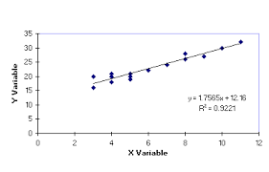Linear regression is an approach for modeling the relationship between a scalar dependent variable *y* and one or more explanatory variables denoted by *X* .

1. Define Safety Stock and Lead Time in Inventory Management System.

***Answer:***

Safety Stock is inventory that is carried to prevent a stock out where there is a uncertainty in the demand or supply process. It functions of lead time demand.

Lead time is the time interval between the time when an order is placed and the time when it is actually received in the inventory. The lead time can be deterministic or probabilistic and constant or time varying.

Q.3) The sales for the last five years are given in the table below. Estimate the sale for year 1979.



***Answer:*** Newton’s Backward difference Method:



P = $\frac{1979- 1982}{ 2}$

P = - 1.5

AS

$y_{x}=y_{n}+p∇y_{n}+\frac{p(p+1)}{2!}∇^{2}y_{n}+\frac{p\left(p+1\right)(p+2)}{3!}∇³y_{n}+\frac{p\left(p+1\right)\left(p+2\right)(p+3)}{4!}∇^{4}y_{n}$

$y_{1979}$ = 57 + (-1.5)(5) + $\frac{ (-1.5)(-0.5)}{2×1}$ (1) + $\frac{(-1.5)\left(-0.5\right)(0.5)}{3×2×1}$ (2) + $\frac{(-1.5)\left(-0.5\right)\left(0.5\right)(1.5)}{4×3×2×1}$ (5)

$y_{1979}$ = 50.1172

Q.4) Armand’s Pizza Parlors is a chain of Italian-food restaurants located in a five-state area. Armand’s most successful locations are near college campuses. The managers believe that quarterly sales for these restaurants are related positively to the size of the student population; that is, restaurants near campuses with a large student population tend to generate more sales than those located near campuses with a small student population. Use Least squares Method to find estimated **regression** equation.

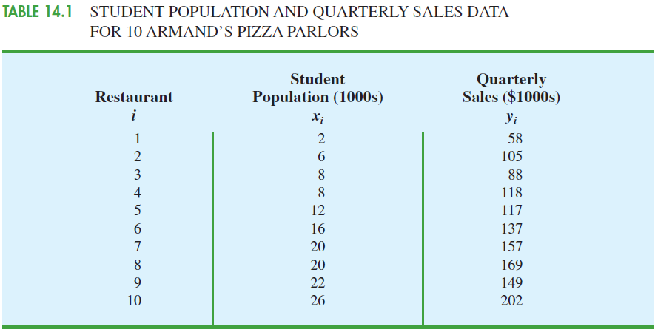

***Answer:***

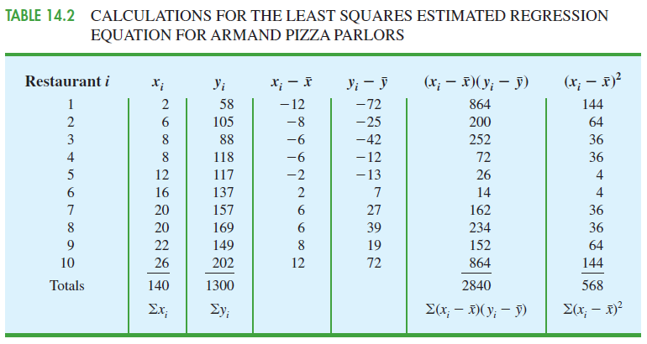

Q.5) The following data represents the number of hours 12 different students watched television during the weekend and the scores of each student who took a test the following Monday.

|  |  |  |  |  |  |  |  |  |  |  |  |  |  |  |  |  |  |  |  |  |  |  |  |
| --- | --- | --- | --- | --- | --- | --- | --- | --- | --- | --- | --- | --- | --- | --- | --- | --- | --- | --- | --- | --- | --- | --- | --- |
| Hours, *x* | 0 | 1 | | 2 | | 3 | | 3 | | 5 | | 5 | | 5 | | 6 | | 7 | | 7 | | 10 | |
| Test score, *y* | 96 | | 85 | | 82 | | 74 | | 95 | | 68 | | 76 | | 84 | | 58 | | 65 | | 75 | | 50 | |

1. Display the scatter plot.
2. Calculate the Correlation Coefficient *r*.
3. Calculate the Coefficient Determination *r2*.

***Answer:***



|  |  |  |  |  |  |  |  |  |  |  |  |  |
| --- | --- | --- | --- | --- | --- | --- | --- | --- | --- | --- | --- | --- |
| Hours, *x* | 0 | 1 | 2 | 3 | 3 | 5 | 5 | 5 | 6 | 7 | 7 | 10 |
| Test score, *y* | 96 | 85 | 82 | 74 | 95 | 68 | 76 | 84 | 58 | 65 | 75 | 50 |
| *xy* | 0 | 85 | 164 | 222 | 285 | 340 | 380 | 420 | 348 | 455 | 525 | 500 |
| *x*2 | 0 | 1 | 4 | 9 | 9 | 25 | 25 | 25 | 36 | 49 | 49 | 100 |
| *y*2 | 9216 | 7225 | 6724 | 5476 | 9025 | 4624 | 5776 | 7056 | 3364 | 4225 | 5625 | 2500 |



There is a strong negative linear correlation.

As the number of hours spent watching TV increases, the test scores tend to decreases



Q.6) A product has a constant demand of 100 units per week. The cost to place an order for inventory replenishment is $1000. the holding cost for a unit inventory is $0.40 per week. No shortages are allowed. Find the optimal Lot size and the corresponding cost of maintaining the inventory.

***Answer:***

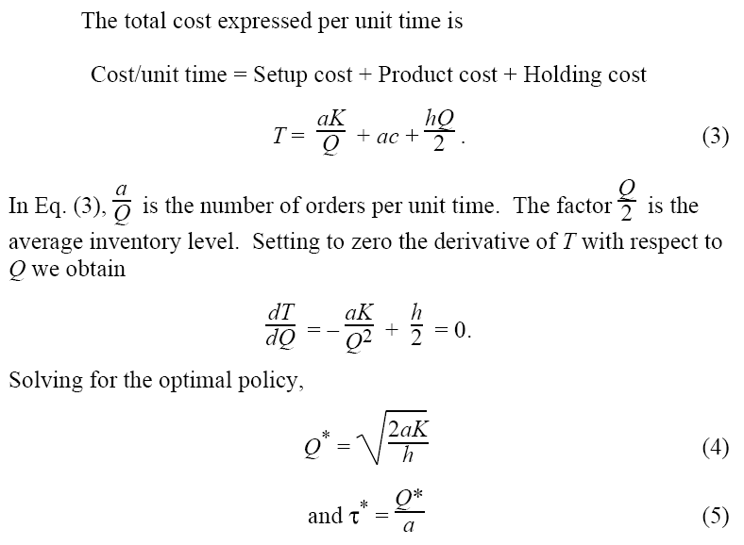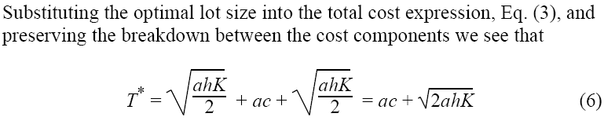

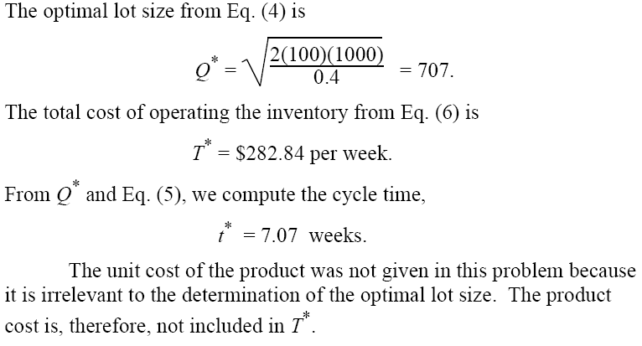

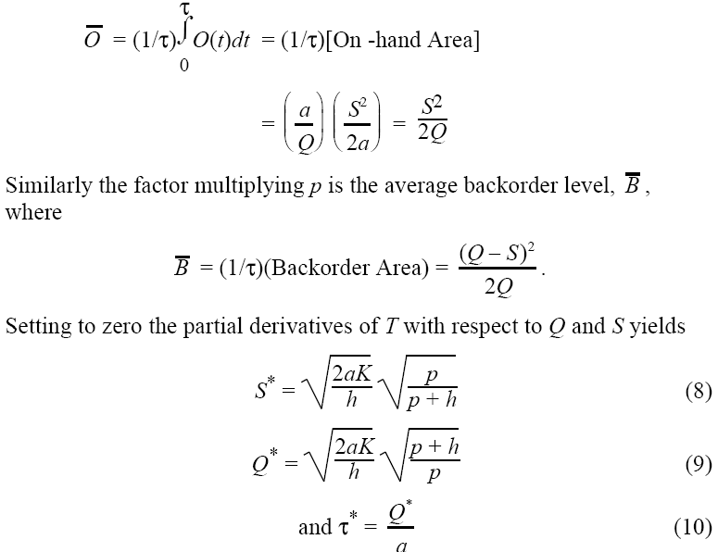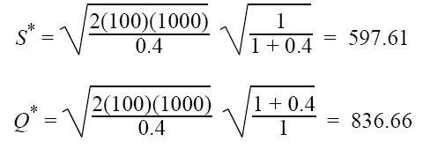

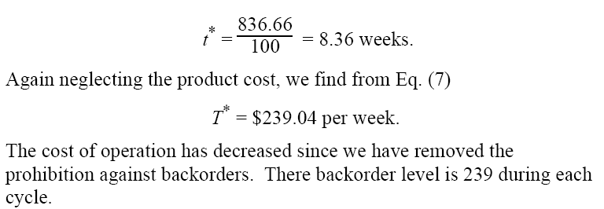

Q.7) Following table shows the monthly Shed sales. Forecast the sales for January of next year using Weighted Moving Average Method.

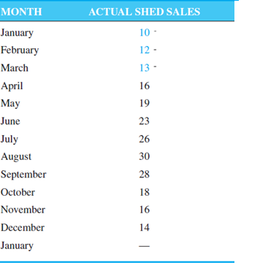

***Answer:***

